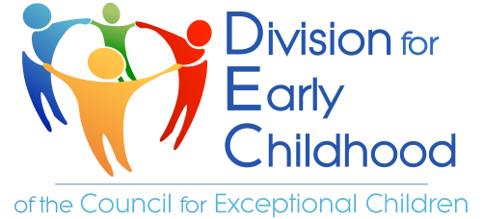
The Executive Board of the Division for Early Childhood (DEC) of the Council for Exceptional Children henceforth publicly commits to advancing the Racial Equity Point of View and ongoing evaluation of internal structures of DEC with a racial equity lens. As an organization that has influenced early intervention and early childhood special education (EI/ECSE) for over 50 years, DEC commits to continuing its work by modeling ways to empower families and professionals that advance equity at the intersection of ability and race to our membership body and beyond.
This statement serves as a promise to our members and the field, that serve young children ages 0-8 and their families, to leverage our ability to influence both individual and structural-level shifts in leadership, policy, research, practice, and partnerships.
We invite and expect our membership to hold the Executive Board accountable and raise the expectations for DEC to serve as an exemplar for and in the field.
Through this statement, the Executive Board commits to ensuring the work of the DEC embodies, aligns with, and integrates the Racial Equity Point of View.
Executive Board Commitments
We acknowledge the power, respect, and freedom of our organization as a catalyst for the entire field and to influence and empower families and professionals to advance equity broadly.
We improve transparency, communicate regularly with members and non-members, and continue to incorporate feedback received to improve an accessible professional organization with its actions.
We continually reflect and take action on the structural and systemic barriers within our organization.
We collaborate with partners that align with the DEC vision and mission.
We recognize and value the contributions from the skill sets that our membership holds and bring forward those that have yet to be recognized in their work.
We seek innovative ways to increase access to membership, engagement, and participation in DEC activities.
We generate ideas with the DEC membership to create forward movement within the field through elevating justice at the intersection of ability and race.
We consistently influence, spread, and create racially equitable practices to those who reach children and families in all environments where they are being served.
We advance innovative theories, frameworks, and methodologies, elevating the research of those subordinated by systemic racism and ableism and promote multidisciplinary studies beyond our field.
We commit to developing these priorities, actions, and sustainable and systematic improvements that will intentionally realize the Racial Equity Point of View.
Respectfully yours,
The DEC Executive Board

Serra Acar
Shameka Brown
Jennifer Francois
Karen Lewis
Ann Mickelson
Megan Purcell
LaShorage Shaffer
Jenna Weglarz-Ward
Hsiu-wen Yang
James Young

